**Exercises**

1. **What speciality had the least duration of wait times?**

The Specialities that has least duration of wait times are: Adult Mental Illness, Nephrology, Paediatrics, Vascular Surgery.

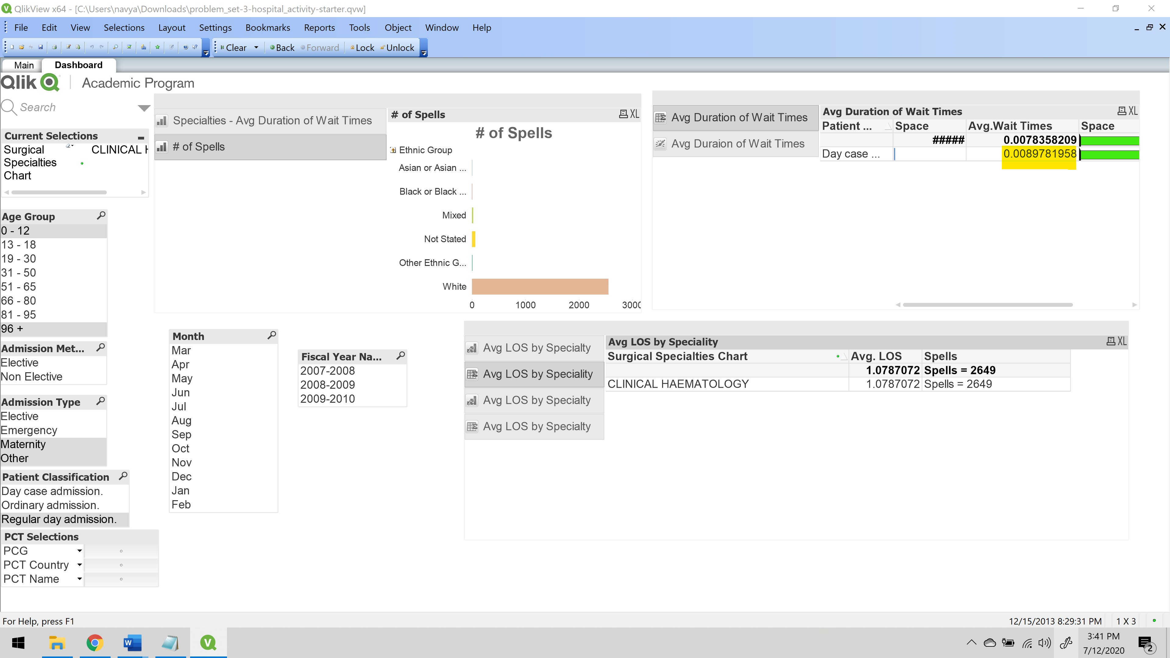

1. **What was the average wait time for Pain Management patients in December of 2008- 2009?**

The average wait time for pain management patients in December of 2008 – 2009: **90.34375**

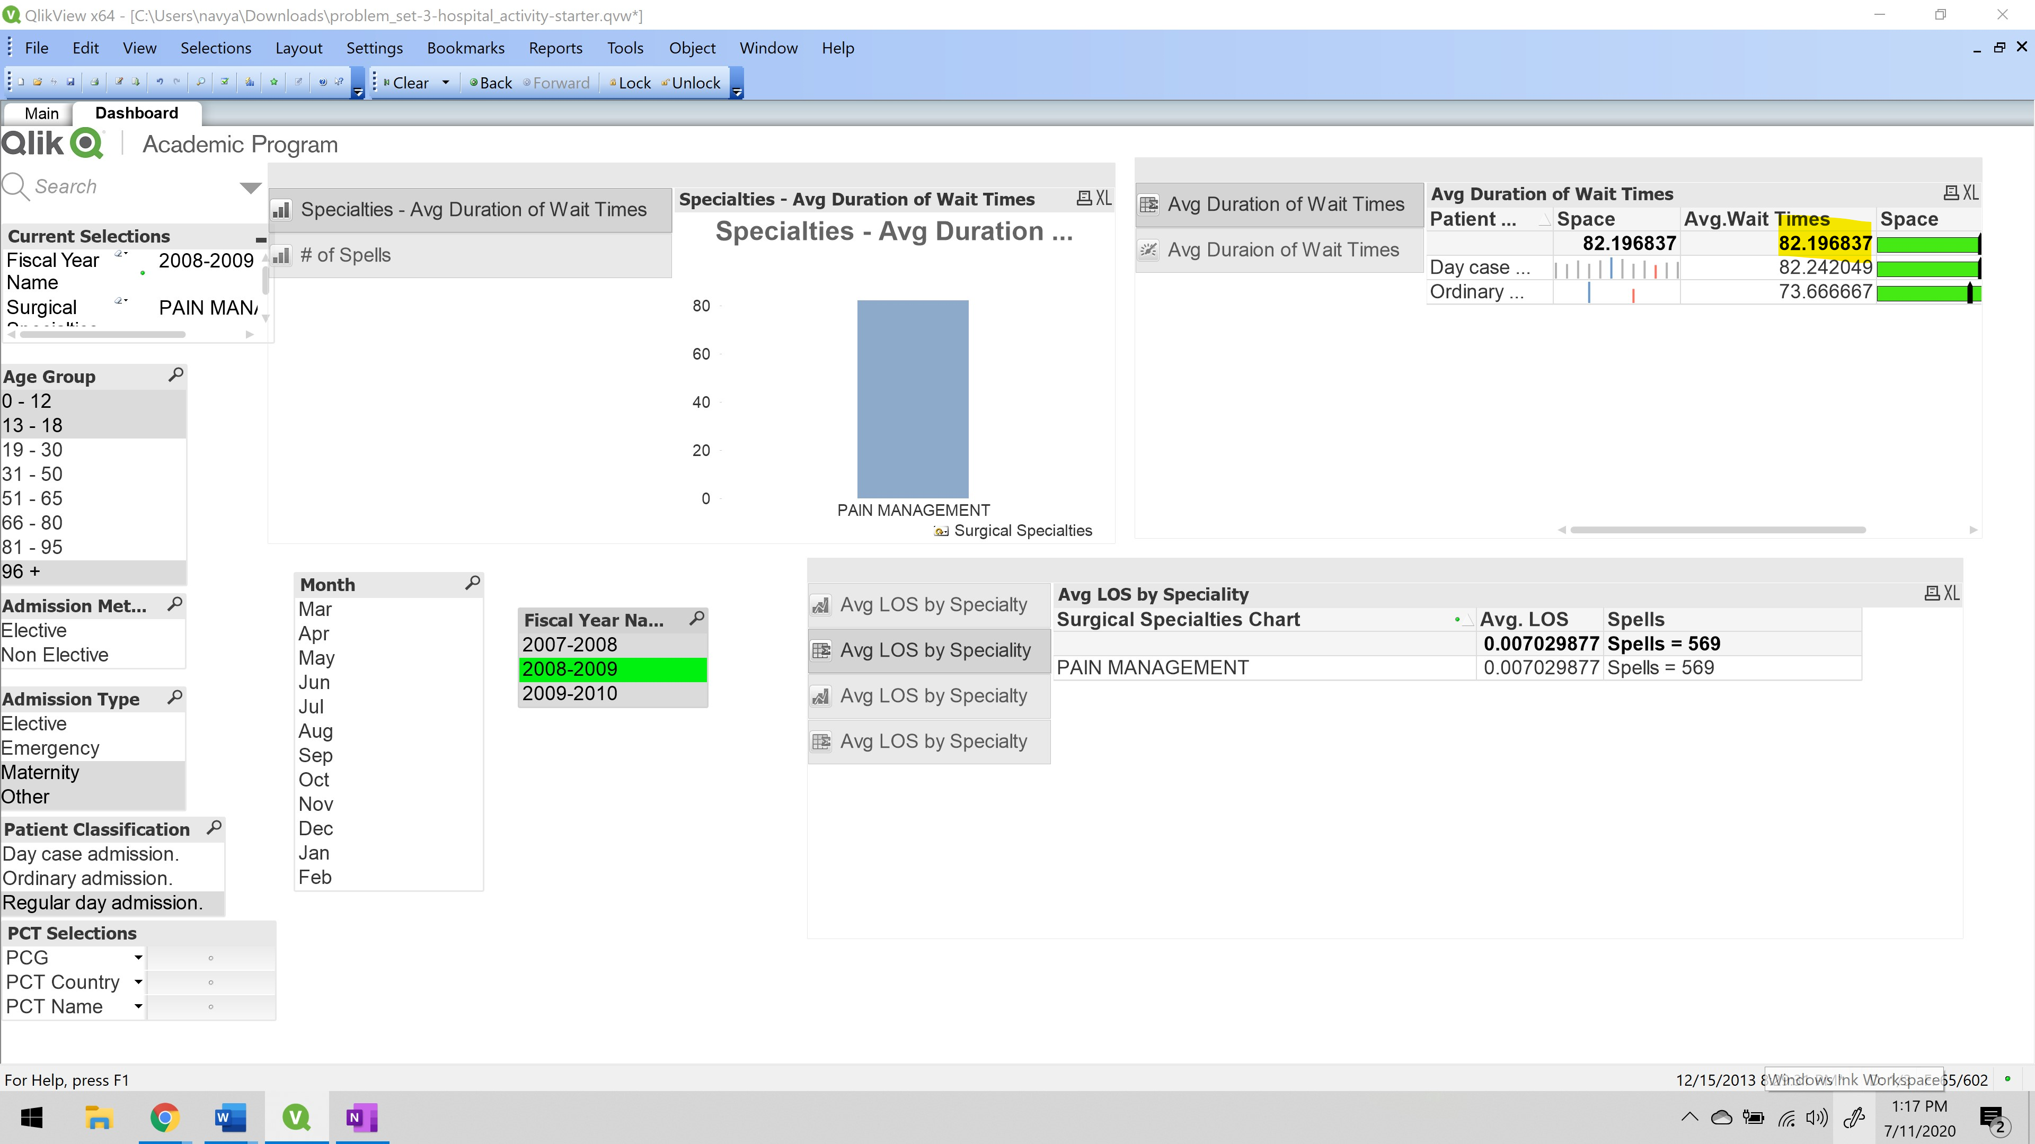

1. **What is the average wait time for plastic surgery patient’s ages 19 -30?**

The average Wait time of plastic surgery patient’s of age group 19 – 30: **40.611475.**

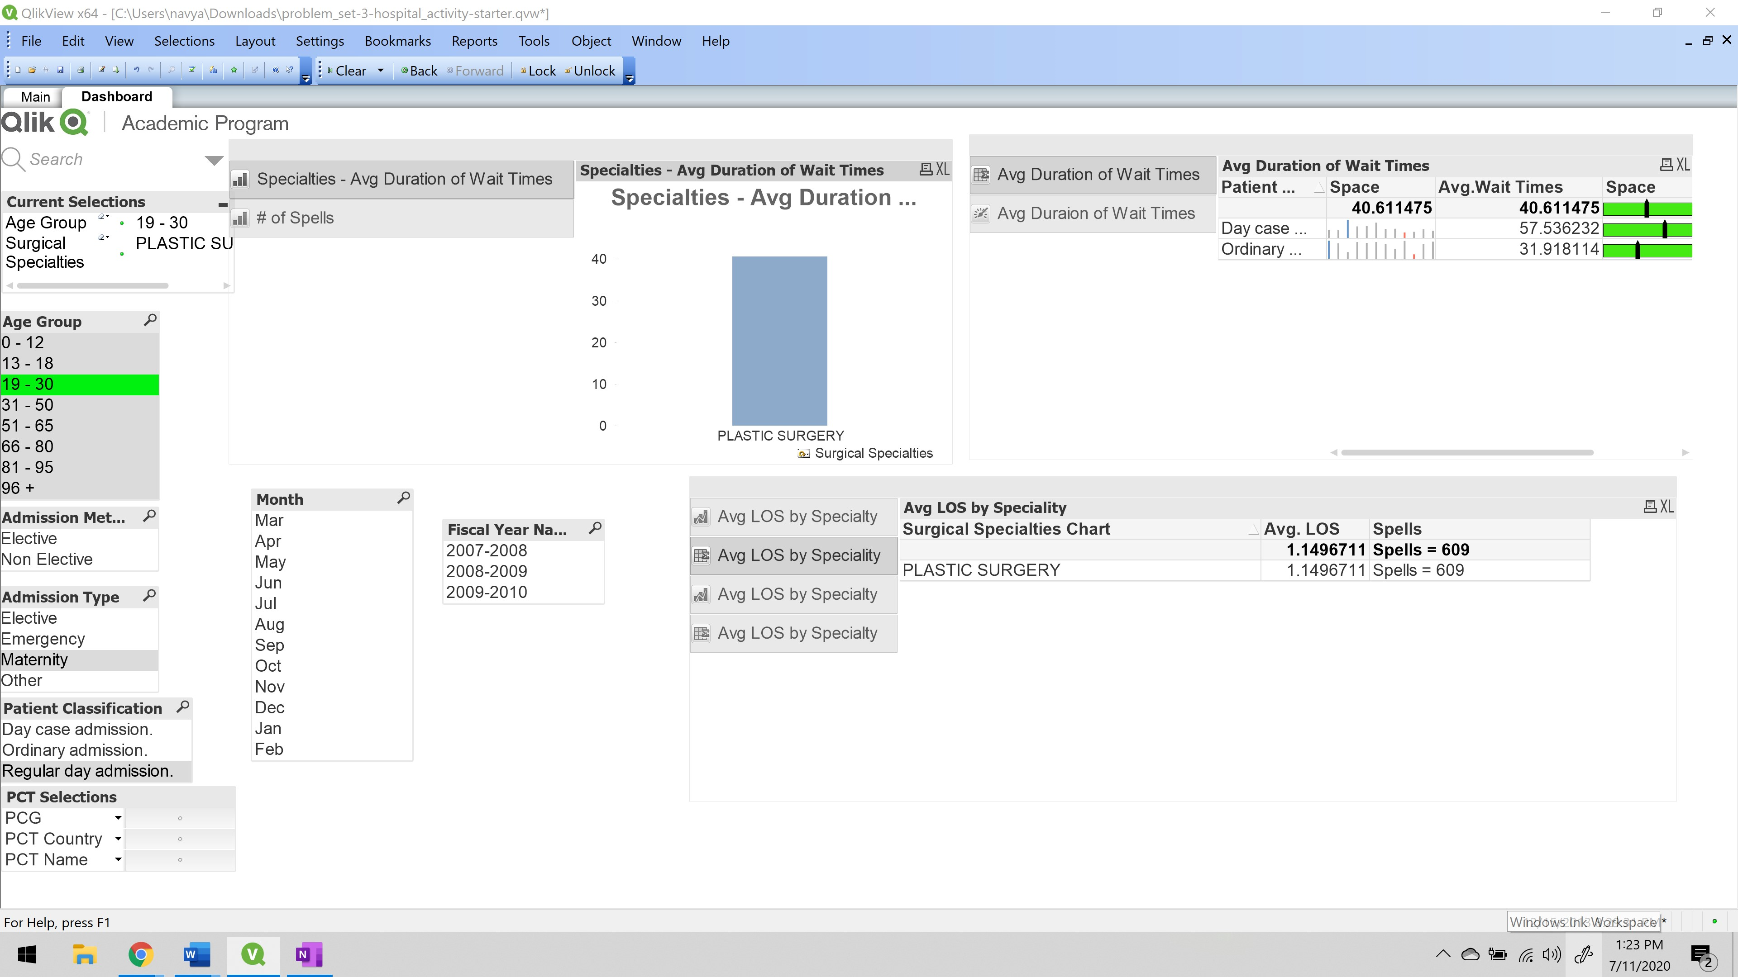

1. **What was the average wait time for day case admission in October of 2009 – 2010?**

The Average wait time for day case admission in October of 2009 – 2010 is **38.505907.**

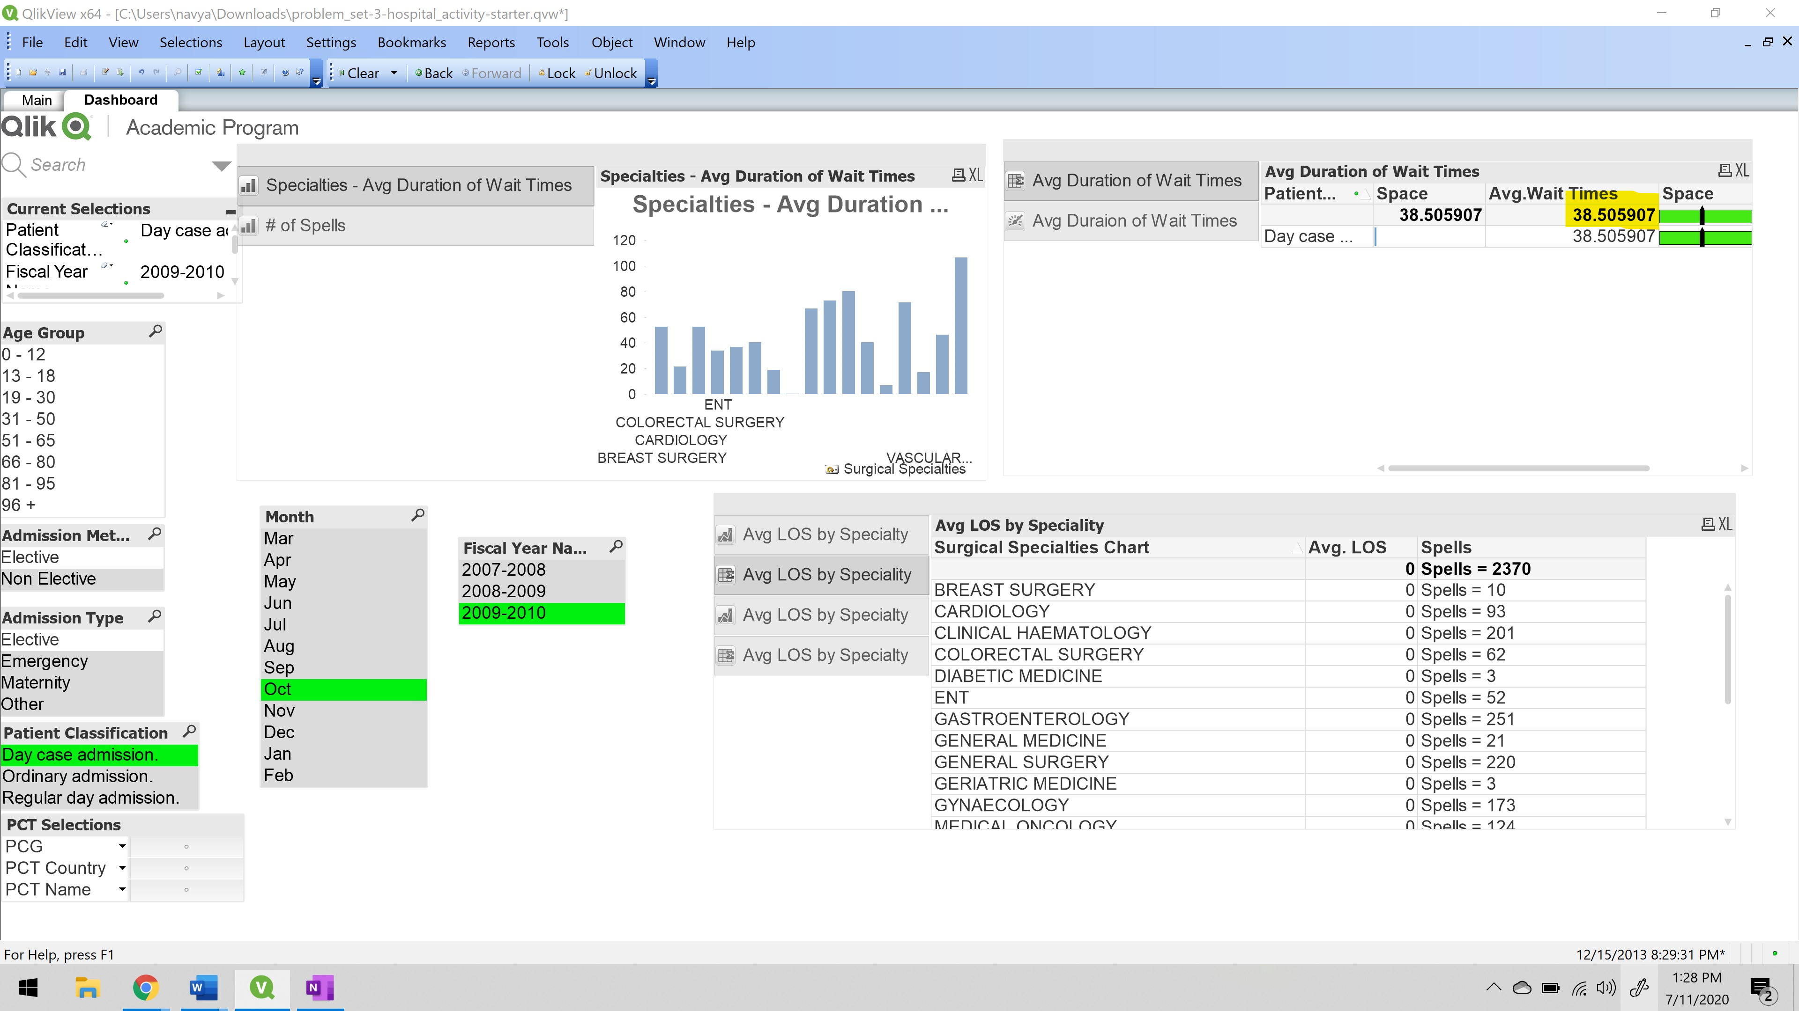

1. **How many oral surgery patients were white during September 2009- 2010?**

Total number of Oral Surgery Patients were white during September 2009 – 2010 is **157.**

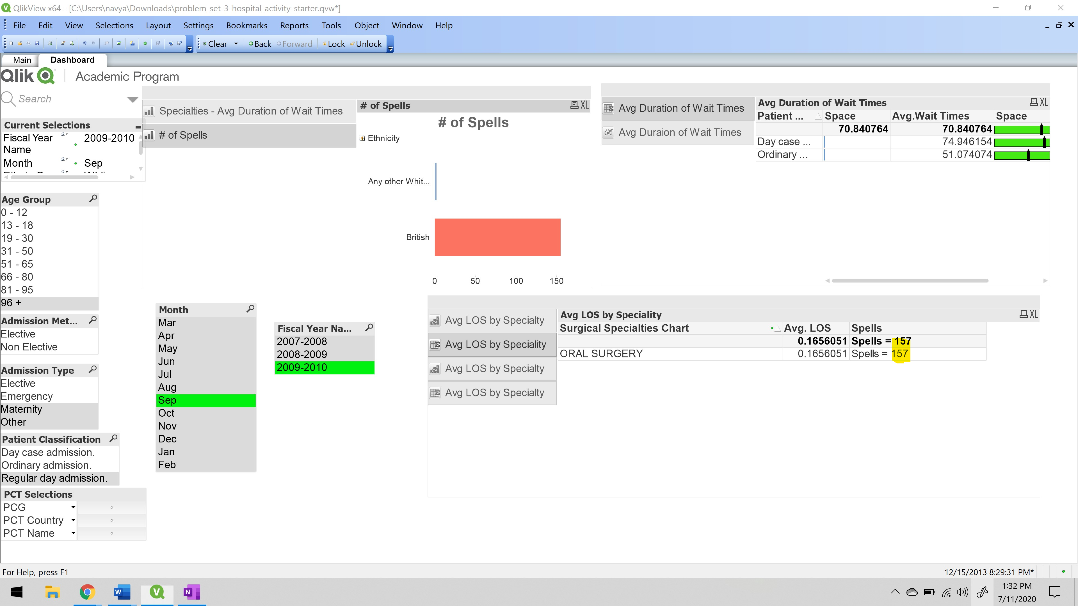

1. **What was the average length of stay for a patient in neurology, both elective and nonelective in August 2009 – 2010?**

The average length of stay for a patient in neurology, both elective and nonelective in August 2009 – 2010: **24**

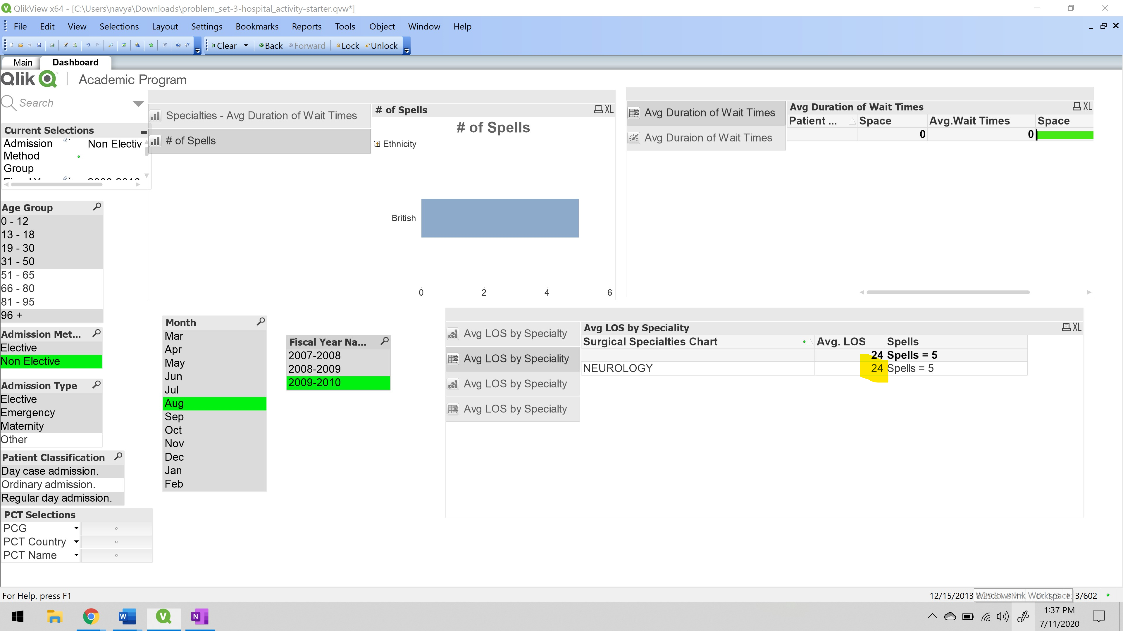

1. **What was the average length of stay for patients in the 81 to 95 age group in August 2008 – 2009?**

The average length of stay for patients in the 81 to 95 age group in August 2008 – 2009: **7.3937754.**

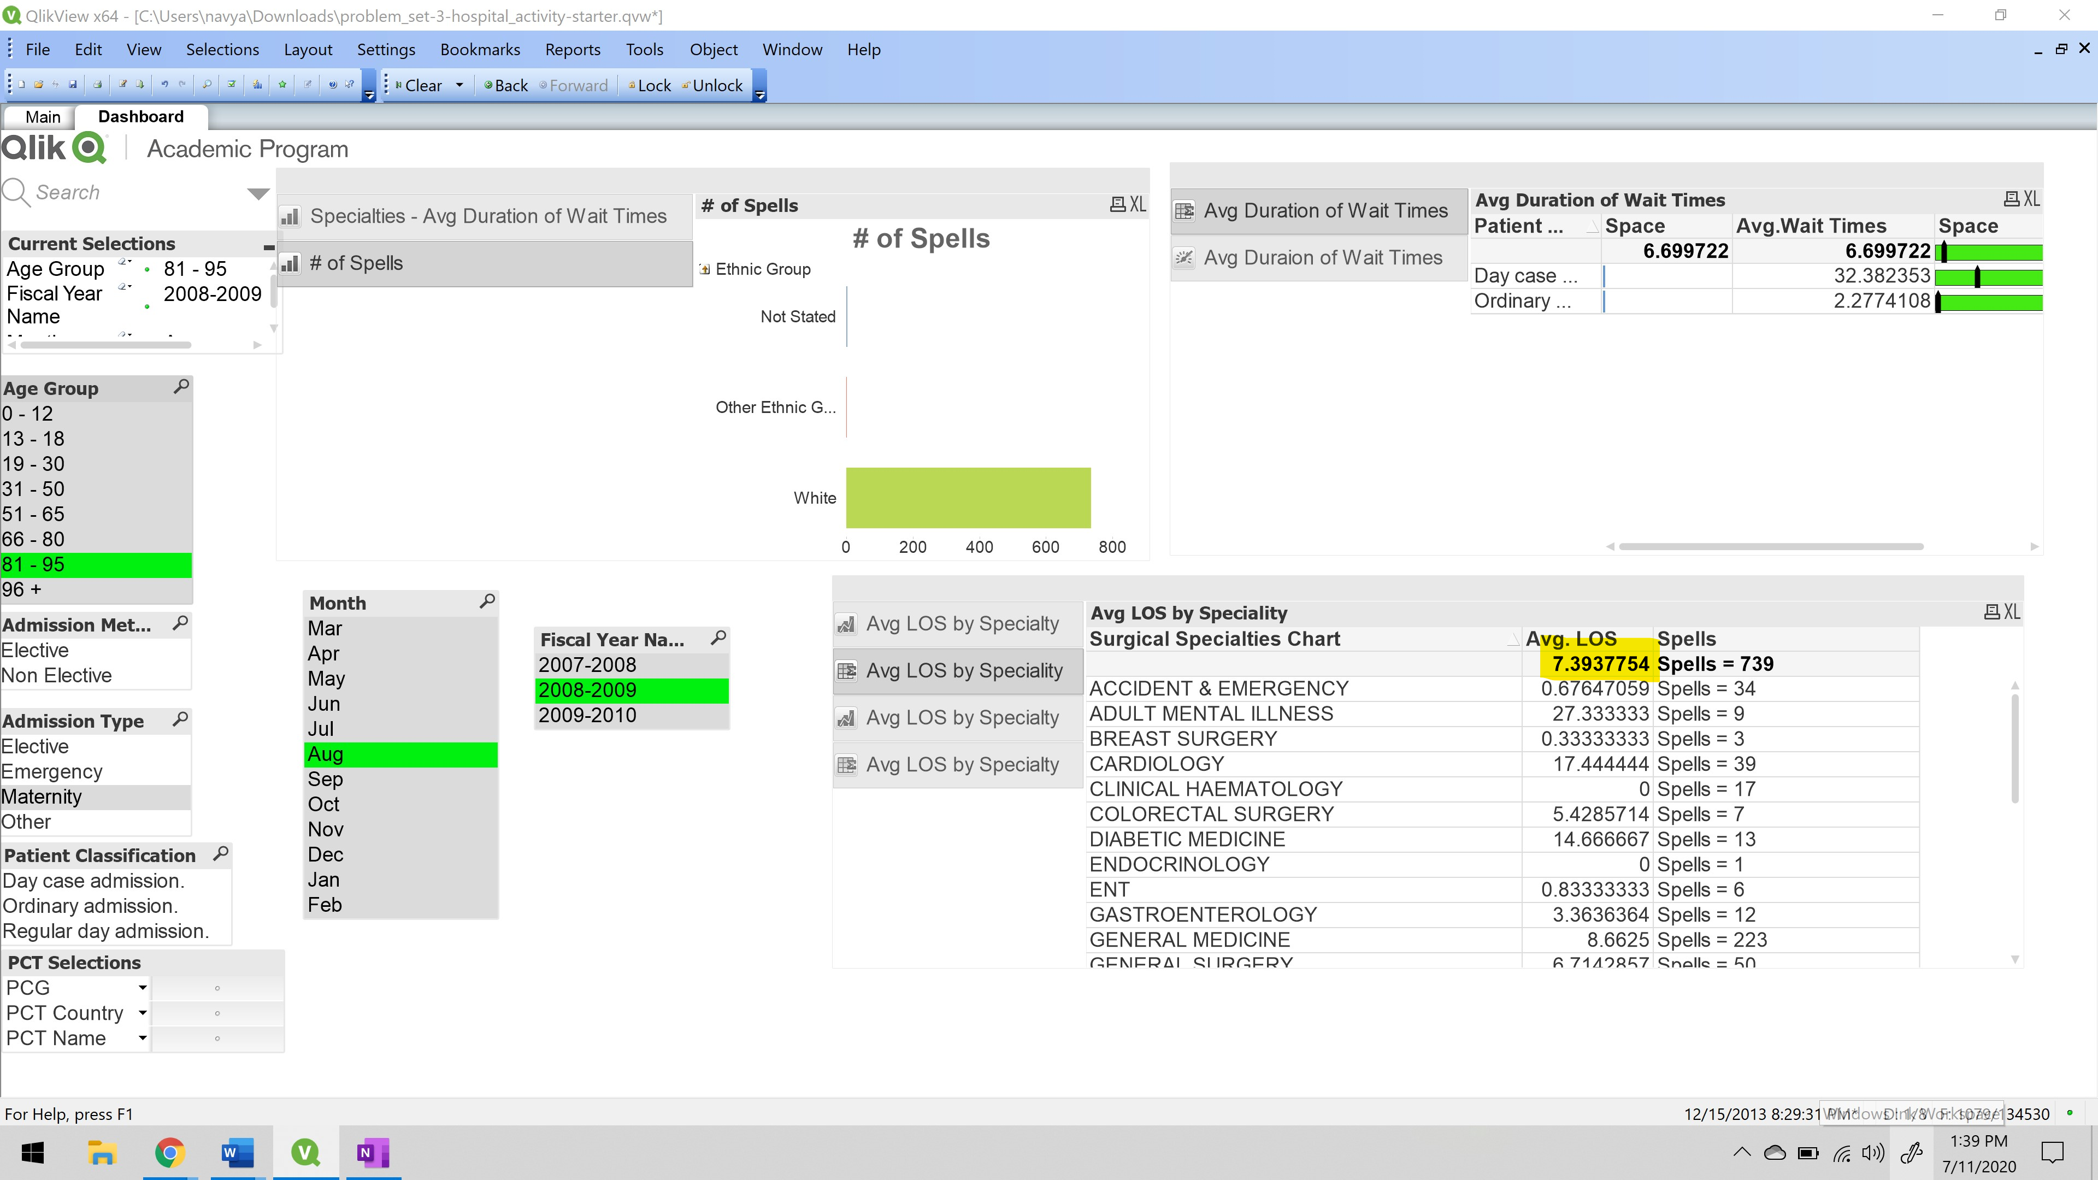

1. **What specialty has an average length of stay of 10.22 days?**

The specialty which has an average length of stay of 10.22 days is **Neonatology.**

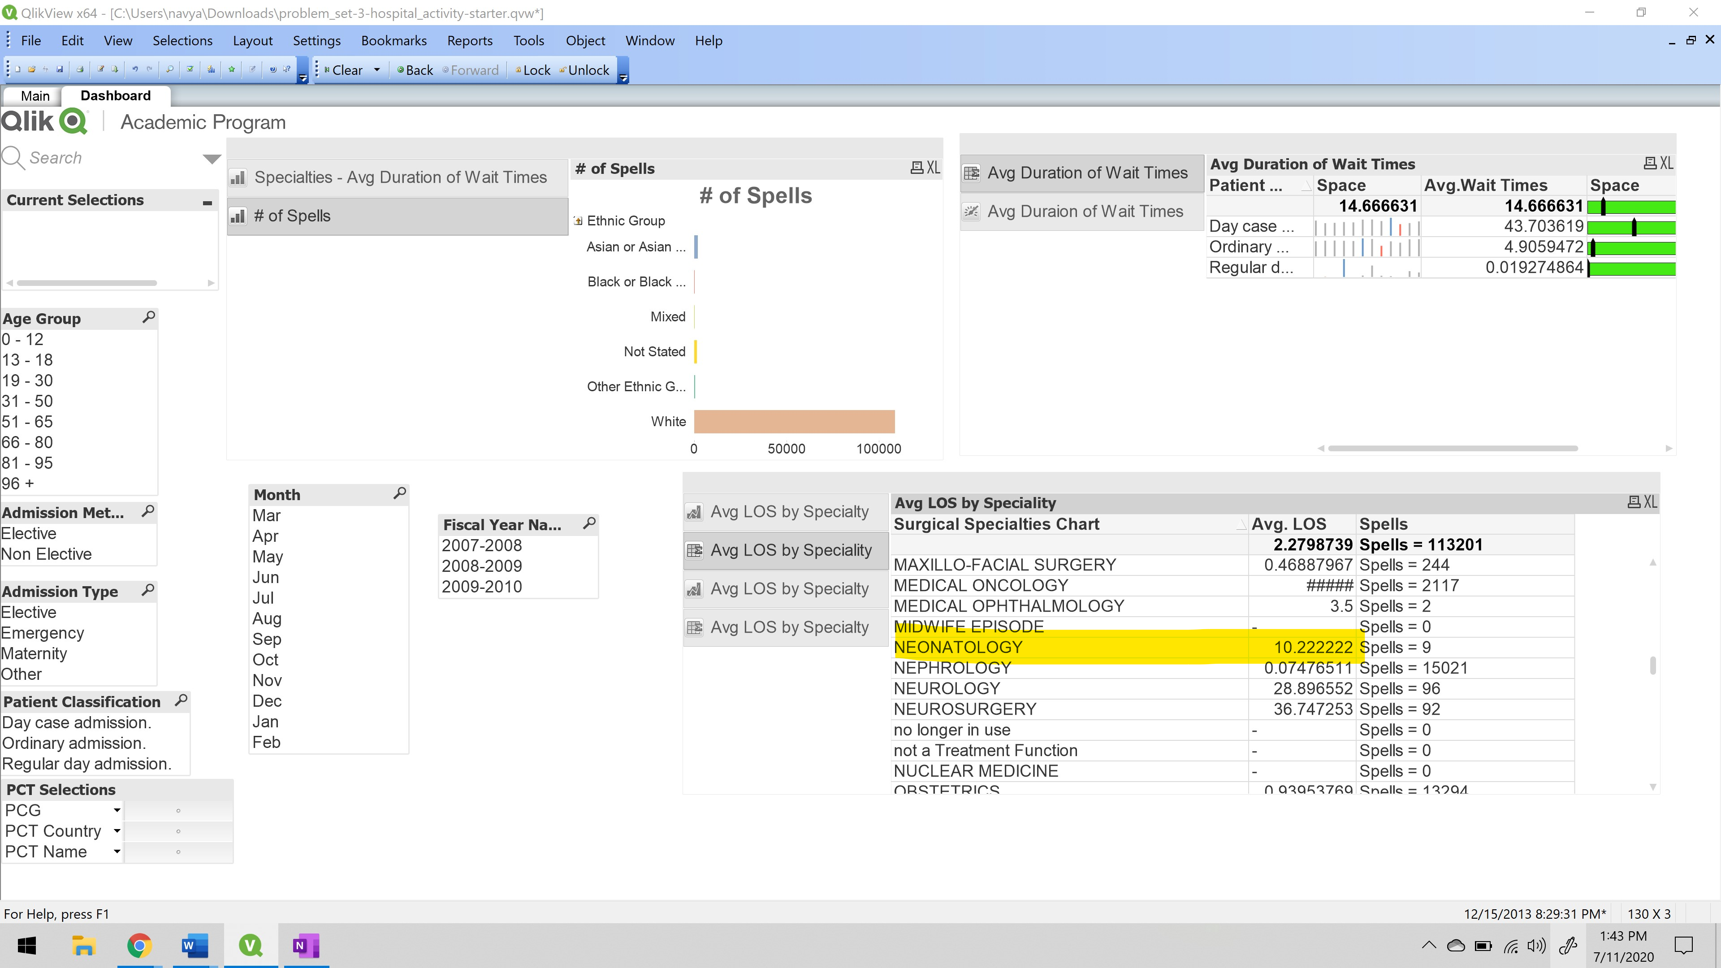

1. **For age group 0 – 12, what is the average length of stay?**

For age group 0-12, the average length of stay is **1.5171127.**

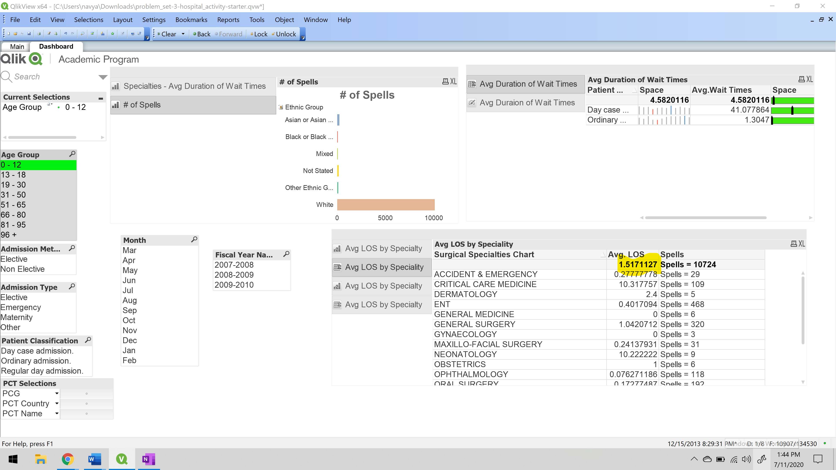

1. **How many spells did emergency pediatrics have from 2007 – 2010?**

Total number of spells the emergency pediatrics have from 2007 – 2010 is **4907.**

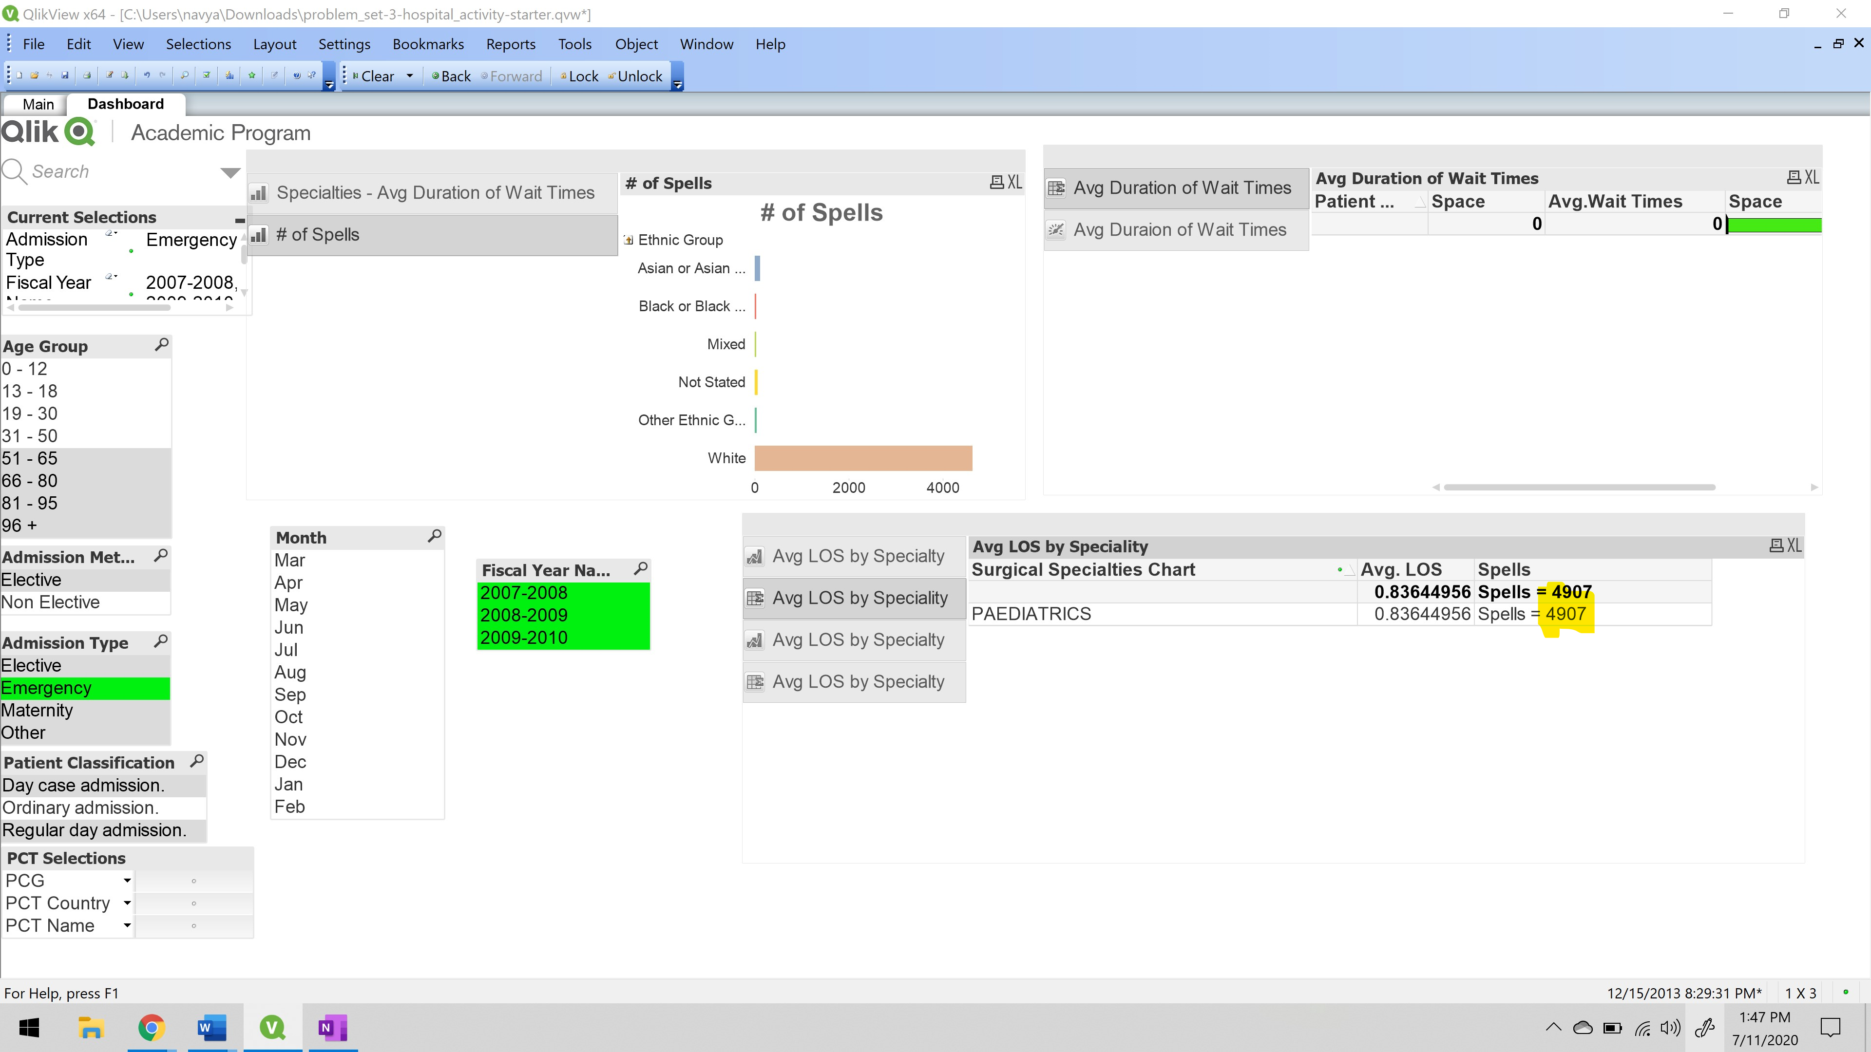

**The difference I found in QlikView and Google Public Data are:**

1. In terms of use the Google charts is easy to use because there is no training required to utilize this google charts in data visualization. Whereas in QlikView Dashboards are also easy to use with minimum training with good visualization.
2. Based on flexibility - Google charts are available at any time and produce the faster outputs, whereas in Qlikview is also the fastest accessible tool.
3. Based on performance – this google charts are occasionally troublesome in terms of connectivity issues but whereas in QlikView the scripting option gives me more options to connect to different databases with ease.

So, these are the few comparisons of Google charts and QlikView.

**References:**

<https://www.trustradius.com/compare-products/google-charts-vs-qlikview>